**Wireframe Document**

International Debt Statistics

|  |
| --- |
|  |

**Revision Number - 1.0**

**Last Date of Revision - 20/09/2022**

**Sharat Achanta**

**Umesh Pawar**

**Document Control :**

|  |  |  |  |
| --- | --- | --- | --- |
| **Date** | **Version** | **Description** | **Author** |
|  |  |  |  |
| 20/09/2022 | 1.0 |  | Sharat Achanta.  Umesh Pawar |
|  |  | Final Revision |  |
|  |  |  |  |
|  |  |  |  |

**Introduction& Problem Statement :**

Problem Statement :

It's not that we humans only take debts to manage our necessities. A country may also take debt to manage its economy. For example, infrastructure spending is one costly ingredient required for a country's citizens to lead comfortable lives. The World Bank is the organization that provides debt to countries.

In this project, you are going to analyze international debt data collected by The World Bank. The dataset contains information about the amount of debt (in USD) owed by developing countries across several categories. You are going to find the answers to questions like:

• What is the total amount of debt that is owed by the countries listed in the dataset?

• Which country owns the maximum amount of debt and what does that amount look like?

• What is the average amount of debt owed by countries across different debt indicators?

**We Performed Exploratory Data Analysis on Jupyter Notebook and then created a Power BI Dashboard.**

Total debt by Country Name :

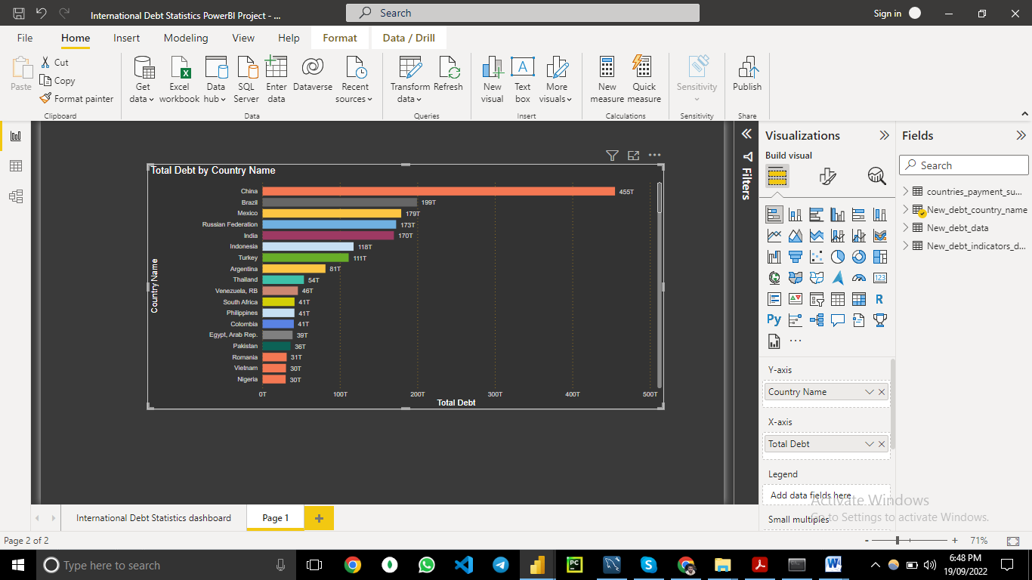

Total Repayment :

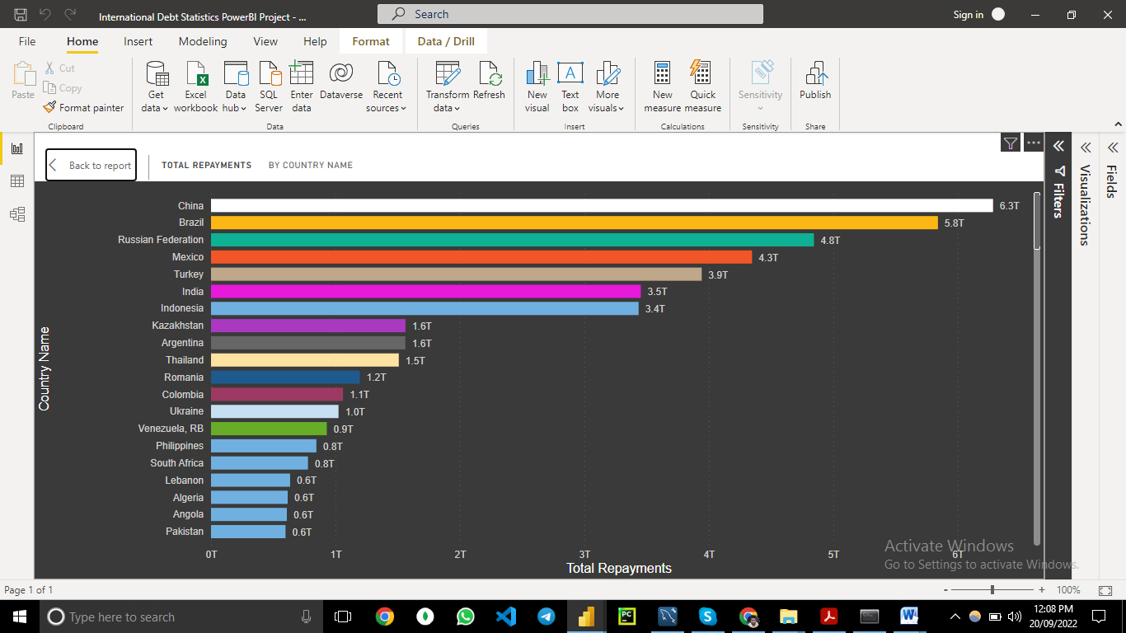

**Country with Highest debt :**

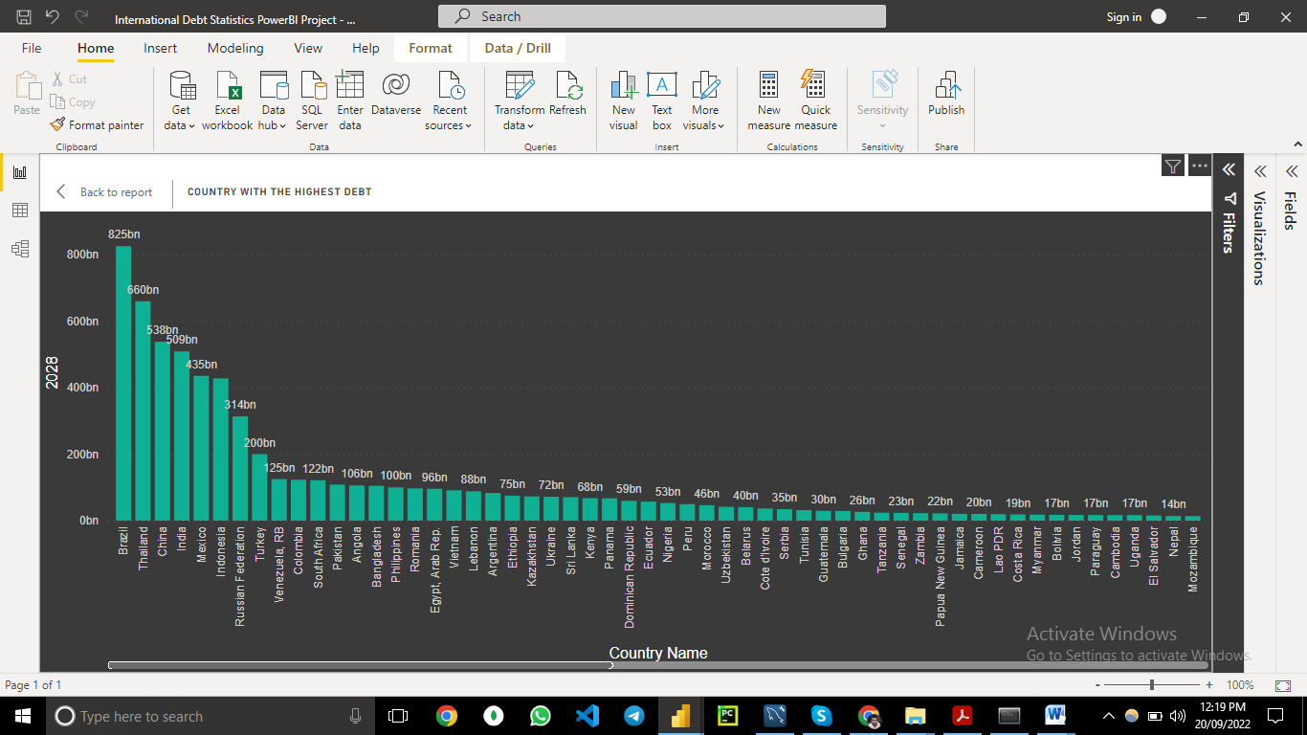

**Power BI DashBoard :**

